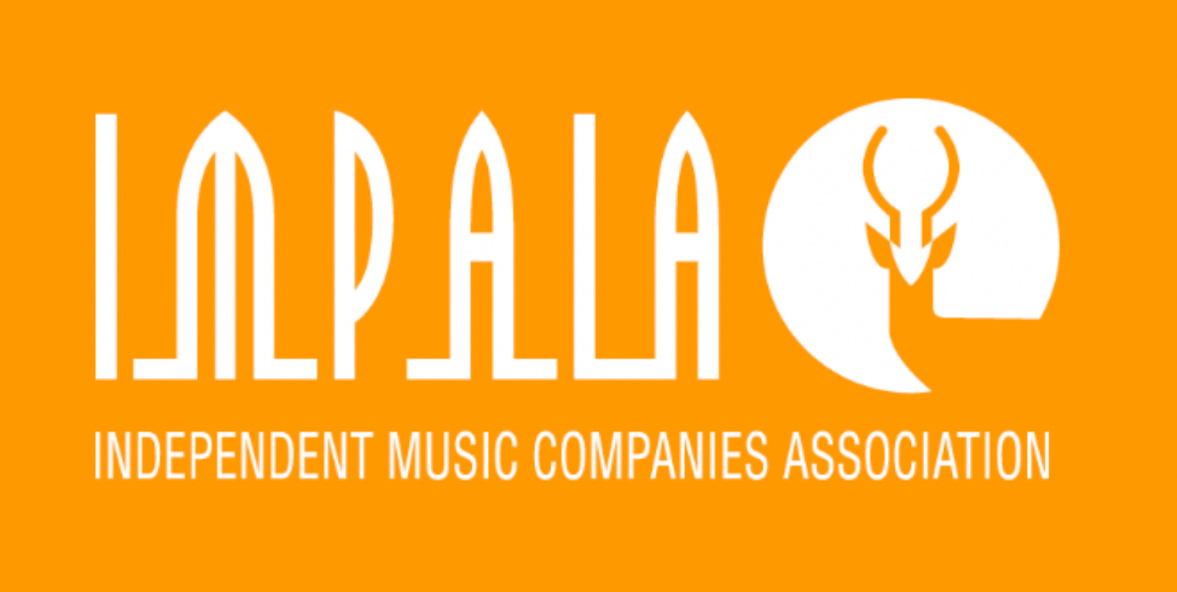 | Guidance for copyright owners in the independent sector on reservation of rights regarding AI use of music

The use of copyrighted works for AI training or machine learning is subject to specific authorisations/licences which need to be secured in advance. To best protect their rights, all copyright owners should clarify their position on this as an additional guarantee. Two steps are advisable:

- Declare on your company website that your rights are reserved, communicate this to all partners to whom you have licensed music and ideally also to AI companies. Here are examples from Beggars, Sugar, Merlin, Warner, Universal and Sony. Your reservation text should take into account the following and should be posted widely (see notes at the bottom of the page):

(COMPANY NAME) Statement regarding AI
- Responsibly produced AI tools have significant potential for the music sector. The rights of all those involved in creating and distributing music must be respected and licensed specifically in advance.

-Without prejudice to any prior rights reservations, (COMPANY NAME) hereby expressly reaffirms that its rights are fully reserved as set out below. We reaffirm that:

-Any past, present or future use of any of the works or content owned or controlled by (COMPANY NAME) (including recordings, audiovisual recordings, compositions, lyrics, artwork, images, data, metadata, etc.) for the purpose of reproducing, performing, distributing, linking to or ingesting, machine learning or any AI training, development or commercialisation of AI systems, tools or technology, web scraping, ripping, recording, altering, making extracts or derivatives, crawling, text or data mining or similar purposes, and by any means (including by automated means), is prohibited, except as specifically and explicitly authorised by (COMPANY NAME) in advance.

-In the absence of an express advance licence permitting the above uses, we expressly reserve our rights in respect of the use of (COMPANY NAME’s) content, including without limitation under Article 4 of the EU Directive 2019/790/EC or similar laws in other jurisdictions (to the extent that this Article would apply to the above uses, an interpretation we do not agree with). Our reservation applies to all content owned or controlled by (COMPANY NAME), now or in the future, including where this content may be identified through publicly available means.

- We will take the necessary steps to prevent the infringement of our rights.

- Please contact us as regards any licensing requests (ADD EMAIL).

- At website and service level, ask your commercial partners to make a similar express reservation of rights clear in their terms and conditions, and to implement technical protection measures to avoid circumvention of rights (e.g. robot.txt). You can make these requests directly or through your distributor, Merlin, etc. You may wish to also specifically write to AI developers directly, as flagged above.

See notes on the next page for more background information.
NOTES FOR IMPALA MEMBERS ON RIGHTS RESERVATIONS FOR AI RELATED USES

1. Industry discussions are ongoing around repositories for these declarations and how they may be centralised. In the meantime, please go ahead and issue your reservations and make them as visible as possible on your website and other public profiles, and to your commercial partners.

2. It’s important to be aware that certain interests claim that copyright exceptions apply to AI training and machine learning (For example the general text and data mining exception (article 4) in the 2019 EU copyright directive). However, this is not the case as exceptions are by nature limited in scope and need to respect the three-step test under international law: exceptions i) only apply in certain special cases, ii) should not conflict with normal exploitation of the work, and iii) should not prejudice legitimate interests of rightholders. On top of this, the exception only applies to works accessed lawfully and third parties do not generally have lawful access to the recorded music of member companies due to existing access restrictions, including technological protection measures, paywalls, terms and conditions.

3. The basic position is that your music can only be used if you give a specific authorisation, but we advise members to be complete with this additional safeguard by confirming that your rights are reserved. That is why we refer to Article 4 which states that the exception in article 4 of the 2019 Directive “shall apply on condition that the use of works (…) has not been expressly reserved by their rightholders, in an appropriate manner, such as machine-readable means in the case of content made publicly available online”. We therefore advise members to make use of this additional safeguard, to protect their works from unlawful use by AI providers. This is an additional guarantee as recorded music is already subject to rights reservations, including through DSPs’ terms of service and through the copyright and phonographic copyright notices that accompany recorded music. Note that the term “opt-out” is sometimes used – we advise avoiding that term altogether because it is misleading (it implies an exception applies).

4. It is advisable for all copyright holders to reserve their rights in this way, whether they are based in the EU or elsewhere. The language above covers legislation in other jurisdictions and can be adapted as necessary.

End

